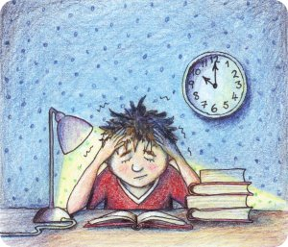

Signs of Stress
- Struggling to sleep

- Negative thoughts – not good enough, will not pass the exams, or get the grades that you want

- Headaches

- Constant worrying about the exams, and difficulty relaxing

- Unable to enjoy anything and worrying a lot

- Panic attacks or anxious feelings – sweating, dizziness, heart beating fast

- Tiredness

- Eating too much or too little

- Feeling irritable and tense

- Exam stress affects everyone – worrying about have you done enough, getting the grades that you want, pressure from home and school and friends…..

Coping with Stress
- Writing down your worries

- Calming music

- Talk to an adult you can trust – parents or guardians, teachers, pastoral care and counsellors

- Talk to a friend that you can trust

- Take breaks – our brain can only take so much information – 1 hour revision. 15 minutes break

- Treat yourself – go for a walk, go out with friends – cinema, read something non related to exams and studying, do some baking – something different from revising that you enjoy

- Plan! Keep space for you in the room you want to revise in. Don’t try and do too many things at once, but also allow yourself a little flexibility

- Eat healthily – we all go for sugar as we think it fuels our brain – but it gives you a high and also a big slump and no energy. Eat regular healthy meals, and the “oh so boring fruit and vegetables!” Home cooked food is best!

- Exercise – get outside in the fresh air to re-energise

- Breathe!

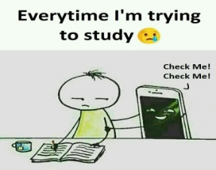
- Self-care – know what your limits are. It’s ok if you are not the same as anyone else – comparing yourself to others will not help you feel any better – everyone is unique as to how they handle stress and how much revision they do. Everyone also remembers and learns differently to you as well

- Sleep – come off social media, mobile phone etc and give yourself “me time”, and relax before going to bed and sleep. Tiredness is normal during this time – remember your brains are taking in a lot of important information at the moment and trying to retain this information as well. This will pass once you have finished and then you can sleep……..

- Think positively – it will be ok and if you don’t get what you need, there are so many other options nowadays. Also, remember, we cannot get away from exams, and they are going to happen!
- Be honest about how you feel – it’s ok not to feel happy and positive all the time – but it will pass. Exams only last for a few weeks
Remember – the more stressed you feel, the less revision you will do – it’s a vicious cycle – the less revision you do, the more you panic etc…
Don’t forget exam stress is normal! Be honest and recognise it when you think it is not normal.
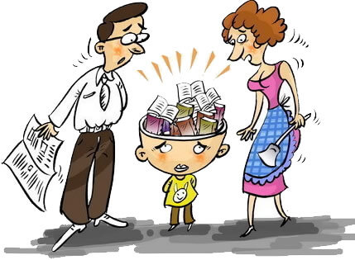
Guide for Parents
- Ensure your child eats well

- Ensure they are getting enough sleep

- Give them flexibility – having breaks is a good thing as it is more beneficial for them – getting out meeting friends or a walk is good

- Can you help them with their studying?

- Listen to them and reassure them – all you can ask of them is to do their best

- Try not to add to the pressure – we know that you want them to do well and get good grades as you are concerned for their future, but being supportive and giving them encouragement, and letting them know not getting the grades is not a failure and not the end of the world!

- Talk to them after each exam, and how your child thinks it went

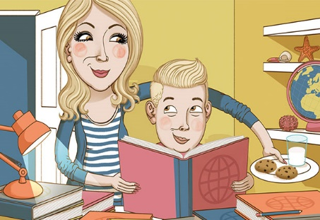
- Treat them – ask them what they would like after the exams – does not need to be expensive – they may just want to go out with their friends to the cinema and have a meal!

