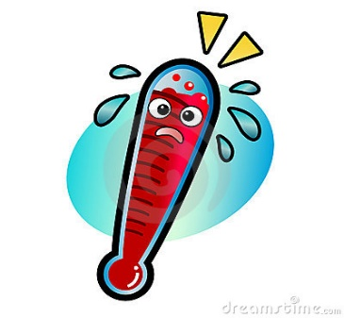

Help ……
Too hot to handle!

Ok, so who does not get angry? What? Never? Seriously???
Who doesn’t want to sometimes just swear at someone? But has to bite their tongue?
Or, wish they could just punch someone, because their buttons have been pushed a little tooooo much?
Yep! I’ve been there! It is ok to have thoughts, but actions can have different and not so nice consequences.
So, what can we do?
Imagine this………

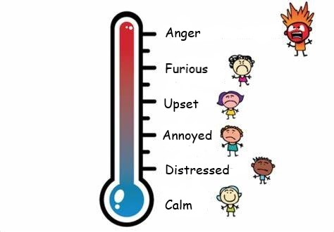

Calm – Hey I am cool and everything is brilliant, and nothing can upset me, and I can deal with whatever comes my way.
Distressed – ok, I can go and talk to someone, and get things off my chest and everything will be ok. Take some time out!
Annoyed/ Upset - when you reach the annoyed / upset stage, you may still be able cool yourself down fairly quickly, by talking to a friend or a trusted adult. Find solutions to the issues. Beyond that can be fairly difficult!
Furious – this may be the point where to have to take a long walk to cool yourself down, and remove yourself from a situation - talk to someone, and try to calm down to express how you feel, once you are more calm.
Anger - If and when you reach the “anger” stage, take a physical step back!
Well, you ask, how can I stop my anger beast before it goes too far?

Here are a few pointers that may help you –

- Physically – take a step back.

- Remove yourself from the situation if you can.

- If possible, think of the situation as the third person, and watch yourself from the outside.

- Choose your fight – is it worth it?

- Process the anger, safely, such as boxing, running, or another physical activity, or talking to an adult e.g. parents/guardians, teachers/counsellors.

- Do some writing, thoughts and feelings, release your anger onto paper, and throw the paper away, screw it up, shred it, or burn it – safely!

- Try to think before speaking, as you can never take back what you have said.

- To avoid criticising or placing blame — which might only increase tension — use "I" statements to describe the problem. Be respectful and specific. For example, say, "I'm upset that you spoke to me this way and called me a nasty name”, instead of “you called me a nasty name and I hate you”.

- Don’t hold a grudge – easier said than done! Forgiveness is powerful, if you allow anger or negative feelings to crowd out positive feelings; you might find yourself swallowed up by your own bitterness – as Buddha said “Holding onto anger is like drinking poison and expecting the other person to die”.

- Use humour to help diffuse a situation.

- Relax! Deep breathing, meditation, music, stretches, writing etc. – all these can help.
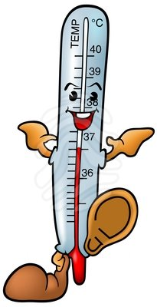

Remember – stay cool! And I hope this helps in some way.

